Bipolar Junction Transistor Bias 

Talha Tallat, Emmanuel Odigie

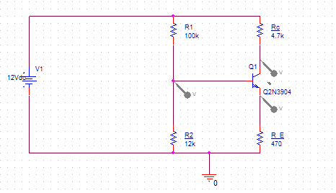

Vc

VB

VE

Figure . Potential Divider Circuit

## **Theory**

To operate as an amplifier the base-emitter junction is forward biased while the base-collector is reverse biased. This is called the active region. An ac signal can now be amplified. A voltage divider network is often used to place the DC bias on the transistor.

## Equations

*DC Base voltage*

$V_{B}=\frac{R_{2}}{R_{1+}R_{2}}V_{cc}$

VE = VB-VBE = VB - 0.7 V

IE=VE/ RE

Vc=VCC-ICRC

Ic  IE

re’ ≈ 25mV / Ie

## Procedure:

1. Using a multimeter, measure the resistance values. Fill in Table 1.

|  |  |  |
| --- | --- | --- |
| Resistor | Nominal value Ω | Measured value Ω DMM |
| R1 | 100K | 98.8K |
| R2 | 12k | 12.2k |
| Rc | 4.7k | 4.6k |
| RE | 470 | 460.8 |

Table .Resistor values

1. Build the circuit. Calculate VB, VE, IE IC, Vc and enter them into Row 1 of Table 2.

|  |  |  |  |  |  |  |  |
| --- | --- | --- | --- | --- | --- | --- | --- |
|  | ***V*B** | ***V*E** | **IE** | **IC** | **VC** | **VCE** | **AC emitter resistance** |
| Calculated | $$V_{B}=\frac{R_{2}}{R_{1+}R_{2}}V_{cc}$$**= 1.2857v** | **VE = VB-VBE = VB - 0.7 V**  = `0.58v | **IE=VE/ RE =**  **1.38 mA** | **Ic  IE**  **1.38 mA** | **Vc=VCC - IC RC=**  5.5v | **VCE=VC-VE=**  4.95v |  |
| Measured | 1.27v | 0.65v |  |  | 5.6v | 4.9v | re’ ≈ 25 mV / IE |
| OrCAD value | 1.284v | 0.69v | 1.503 mA | 1.499 mA | 4.908v | 4.218v |  |

Table . Measurements. Note you do NOT measure current using the Ammeter function of the DMM. Use the resistors as current sensors – ask me about this!!

1. Fill in Row 2 as follows. Apply a 12 V supply between Vcc and Gnd terminals of the circuit. Do not apply an ac signal to the circuit. Using the DMM, **measure** VB, VE. Using the **measured** value of VE, calculate the value of IE. Since IC ≈ IE, you can enter the IE value in the measured IC column. Calculate the value of Vc using measured values for Ic. Measure the value of VCE. **Calculate** the transistor ac emitter resistance using the **measured** IE.
2. Do a Bias point simulation with OrCAD and fill in Row 3.
3. Write one comment on the work you have done.

**Comment:** This semantic diagram as shown below was built in OrCad to measure the volts across ${ V}_{B}, VE, IE, Vc, Ic$. The first table is the resistors measured values measured with help of a digital multimeter (DMM). The second table are the measured values from the digital mustimeter and theory calculations and OrCad Values. The formulas were given to calculate the ${ V}_{B}, VE, IE, Vc, Ic$. The values were displayed as expected.

